Lab Activity 2

Objectives
- To design a functional Notification Screen using Flutter widgets.
- To implement a scrollable list of notifications with dynamic design

Materials Needed:
- A computer with Flutter installed.
- A code editor (like VS Code or Android Studio).
- The provider package installed in your Flutter project.

Instructions:
Modify and update the previous version of the app in the last activity.
Replicate the code snippet.
Follow and implement the enhancement instructions.

Steps:
Use the previous source code [surname_mobprog]
Update the design pattern by adding the two [notification_screen & notification] .dart files
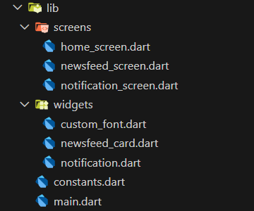

Sample output.
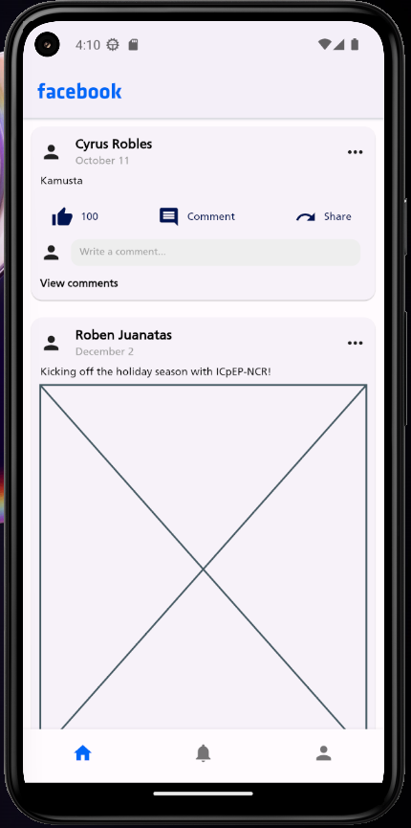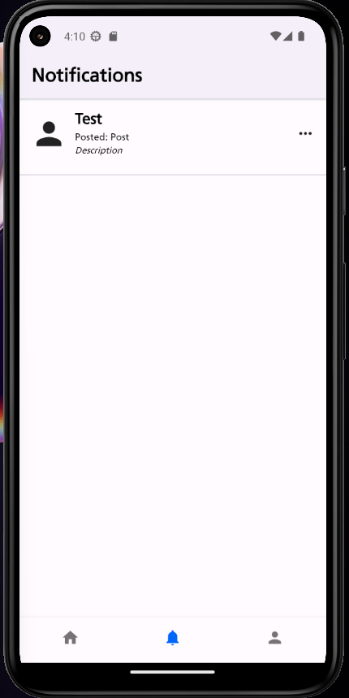
notification.dart
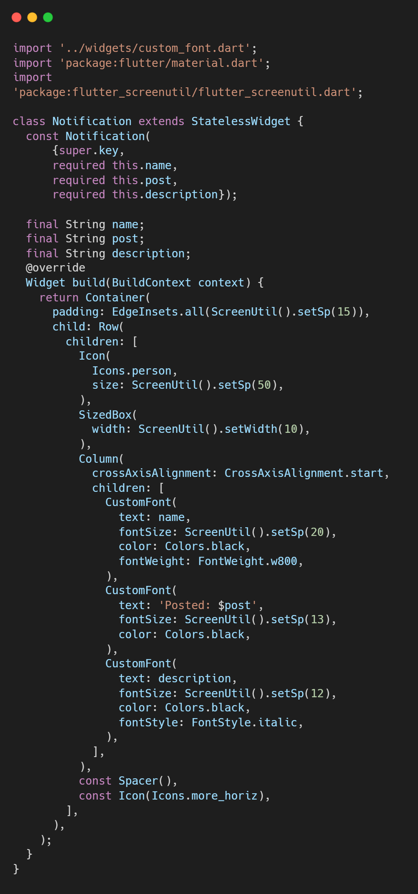
notification_screen.dart
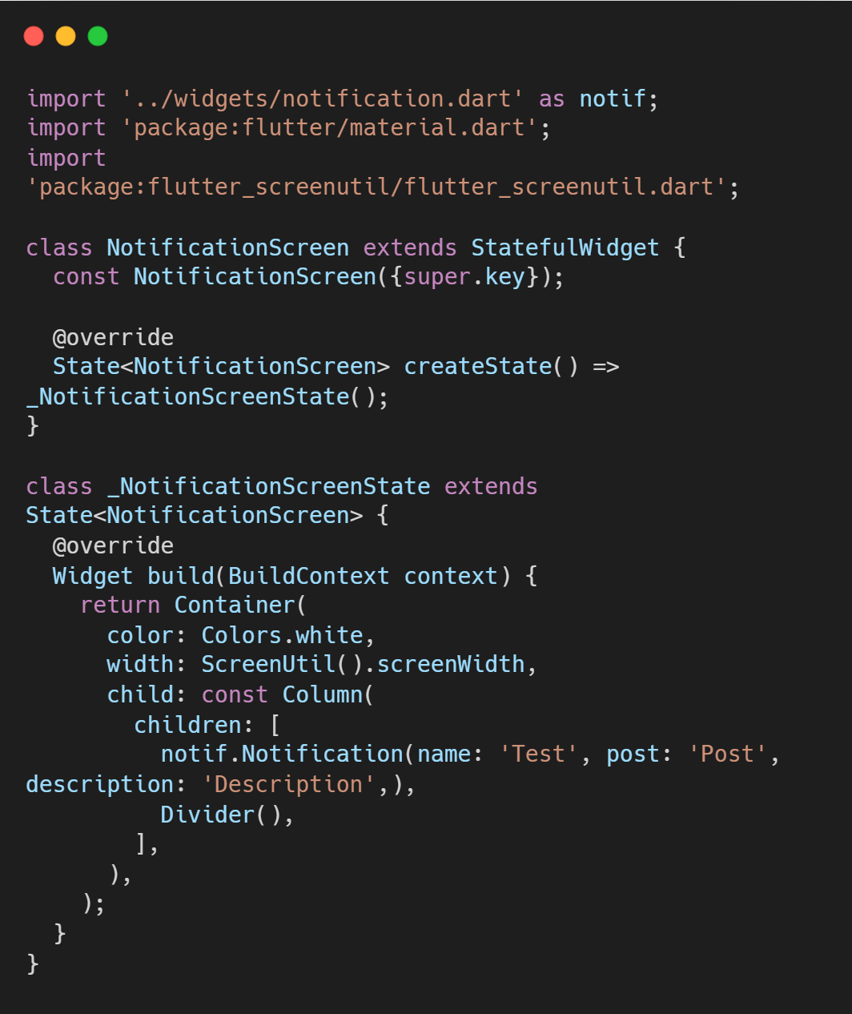

Enhancement Instructions:
General Enhancement: Add 5-10 post and 10-20 notifications



Enhancement 1: Create a dynamic post with these considerations:
- Assigning number of values.
- Assigning date in every post
- Whether a post has a placeholder or none.

Enhancement 2: Create a dynamic AppBar title.
Enhancement 3: Add more BottomNavigationBarItem.
Enhancement 4: Change the App name into your own social media application name.
Enhancement 5: Change the color palette based on your preference. You can use color palette link as your reference.
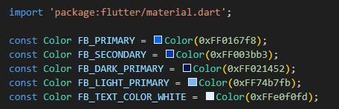
Please update your color palette on the constants.dart file.
COLOR PALLETE LINK: sample color palletes

Activity Rubrics

Criteria | Excellent (4 pts) | Good (3 pts) | Fair (2 pts) | Poor (1 pt) | Points
Code Implementation | Code runs flawlessly, includes all required features (placeholders, avatars, widgets for like/comment). | Code mostly correct, minor errors, or missing one minor feature. | Noticeable errors or missing two or more features. | Code does not run or is significantly incomplete.
Design Consistency | UI closely resembles intended layout, proper spacing, alignment, and styling. | Layout mostly accurate, minor spacing or alignment issues. | Layout deviates significantly from the intended design or appears incomplete. | Layout is unrecognizable or does not follow the instructions.
Use of Widgets and Enhancements | Properly implements widgets for placeholders, avatars, and like/comment buttons. | Most widgets are correctly implemented, with minor issues or missing one enhancement. | Widgets are inconsistently used or missing two or more enhancements. | Widgets are not used, or enhancements are not implemented.
Code Organization and Readability | Code is well-structured, follows best practices, and adheres to the specified file organization. | Code is mostly organized and readable, minor deviations from the required structure. | Code is poorly organized or does not follow the specified structure. | Code is disorganized and difficult to understand.
 | Other Comments/ Observations: |  |  | Total Score
 |  |  |  | Rating: (Total Score/16) * 100

